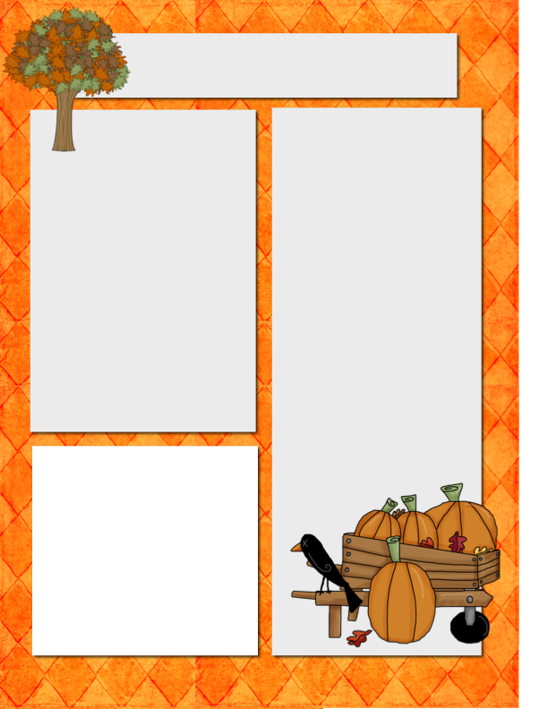

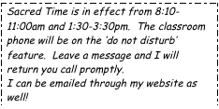

E-Mail: Jquagliotto@pacek-8.org

Phone: (248) 569 – 1060 Ext. 2203

Website: JQuagliotto.weebly.com

**My Contact Information!**

**Coming Up**

* Reading: Students will be learning about Main Idea. We will also continue Ebli in the classroom.
* Math: Student will be finishing place value. We will also be starting long division!
* Science: We will continue learning about Forces in Motion!

Quagliotto Times

***October 2, 2015***

**Dates to**

**Remember**

October 7 Count Day

October 13 Progress Reports

**October 13 Board of Directiors Meeting**

**October 16 NO SCHOOL**

**October 22nd R.E.A.L Parents Meeting**

**October 23 – 31 Red Ribbon Week**

**October 30 Jeans Day ($1.00)**

**Please Note…**

Book orders for this month are due on OCT 15th



**October Core Value: INTEGRITY**

Please make sure your students are reading 20 minutes every night!!!

**Mackinac** **Island Field Trip**

Students in 5th grade have an opportunity to go on a class field trip to Mackinac Island in June. This is an overnight trip. The total price is a low as $180. It is an awesome opportunity for the students, and I would love to see many students from this class go. Students who are interested need to pay a deposit of $50 ASAP. Any questions about this please contact Mrs. Ramirez. Her e-mail address is [lramirez@pacek-8.org](mailto:lramirez@pacek-8.org).

**Remind 101**

If you would like text reminders for events and tests, please sign up on Remind 101.

To sign up, send a text to (586) 447-7338 with the message @7531f3

Or send an e-mail to [7531f3@mail.remind.com](mailto:7531f3@mail.remind.com)

You can leave the subject and message blank.