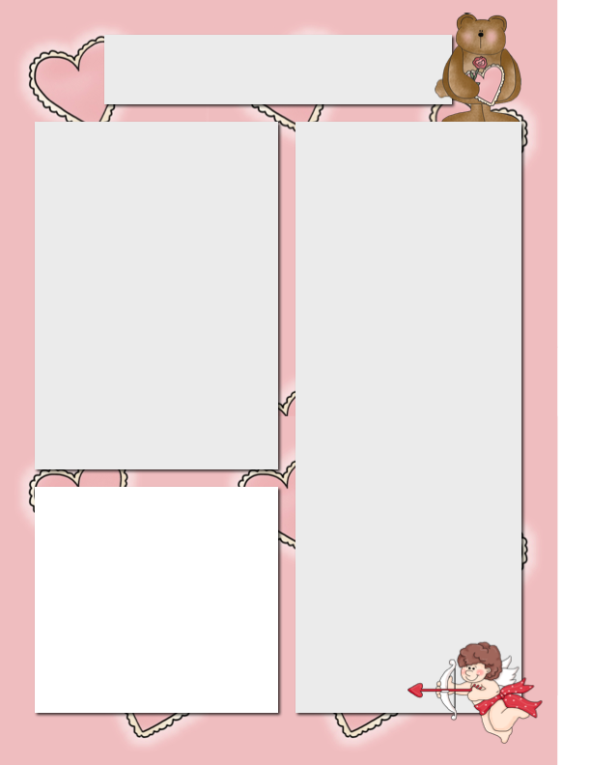

E-Mail: Jquagliotto@pacek-8.org

Phone: (248) 569 – 1060 Ext. 2203

Website: JQuagliotto.weebly.com

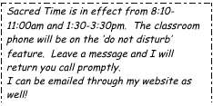

**Coming Up**

* **Reading**: Students have started their new reading groups. Each group work is due every week. If your students loose their sheets please look on the website. In class, students are exploring close reading and cause and effect.
* **Math**: Students will be finishing adding and subtracting fractions and moving on to multiply and dividing them.
* **Science**: Students will be studying heredity and genes.

Quagliotto Times

***February 1st, 2016***

**My Contact Information**

**Dates to Remember**

Feb 9 & 11 Parent Teacher Conferences

Feb 11 Board Meeting

Feb 13 – 21 Mid-Winter Break

Feb 23 Progress Reports

Feb 25 R.E.A.L Parents Meeting

Feb 25 5th Grade Wax Museum

Feb 26 Jean Day ($1.00)

**Please Note…**

Book Order DUE February 12th



Reading Logs DUE every FRIDAY!!!

**Remind 101**

If you would like text reminders for events and tests, please sign up on Remind 101.

To sign up, send a text to (586) 447-7338 with the message @7531f3

Or send an e-mail to [7531f3@mail.remind.com](mailto:7531f3@mail.remind.com)

You can leave the subject and message blank.

**Supplies Needed**

1. Tissue Boxes
2. Hand Sanitizer
3. Paper Towel
4. Glue Sticks
5. Pencils
6. White board cleaner
7. White board markers
8. Sticky Notes

**Class Website**

Please make sure you are looking at the class website frequently. I updated it weekly. It includes copies of homework and assignments. If you have any questions, please let me know!

JQuagliotto.weebly.com

**Classroom Restock**

The classroom can really use some more supplies to keep us set for the remainder of the school year!