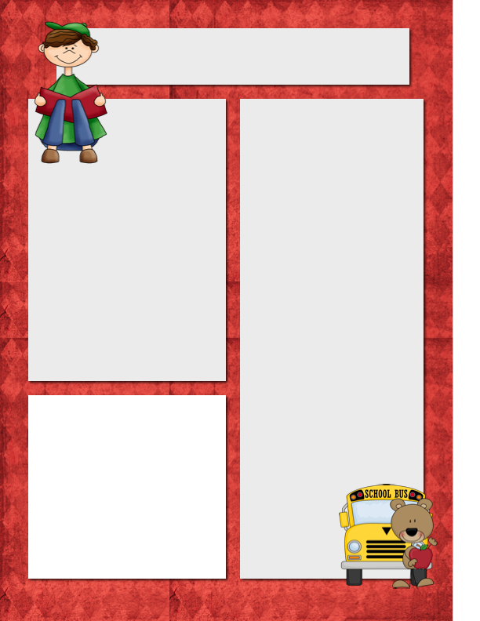

E-Mail: Jquagliotto@pacek-8.org

Phone: (248) 569 – 1060 Ext. 2203

Website: JQuagliotto.weebly.com

**My Contact Information**

*Sacred Time is in effect from 8:10-11:00am and 1:30-3:30pm. The classroom phone will be on the ‘do not disturb’ feature. Leave a message and I will return you call promptly.*

*I can be emailed through my website as well!*

Quagliotto Times

***September 21st, 2015***

**Coming Up**

* Reading – This year in reading your student will be enhancing their reading skills using many resources such as Storytown books. We will also be using EBLI to improve reading skills!
* Science – Students will be creating interactive notebooks. They will be also using Discovery Education for many labs and resources!
* Math – Students will be using My Math to help engage them in new topics though out the year.

**Dates to Remember**

Sept. 25 Book Order DUE

Sept. 25 Jeans Day ($1.00)

**Please look at 5th Grade website!**

[http://pace5thgrade.weebly.com](http://pace5thgrade.weebly.com/)

**Please Note…Remember to bring in school supplies!**



**About ME**

My name is Jean Quagliotto, and I am so excited to be your child’s 5th grade teacher this coming school year.  This is my second year at PACE Academy and I am excited to see where the school year will go. I am a graduate of Oakland University and have a major in Math and Science. One of my favorite things to do in my free time is to read books, and I cannot wait to share that love with your children. I also really enjoy traveling and getting to explore new places and try new things. In the last few years I have had the opportunity to go to Mexico, China, Japan, Australia and New Zealand. I am so excited to get to know you and your student throughout the remainder of the school year.

**Homework to Expect**

**This Week**

Monday: blah, blah, blah, blah, blah, blah, blah, blah, blah, blah

Tuesday: blah, blah, blah, blah, blah, blah, blah, blah, blah, blah

Wednesday: blah, blah, blah, blah, blah, blah, blah, blah, blah, blah

Thursday: blah, blah, blah, blah, blah, blah, blah, blah, blah, blah

**Remind 101**

If you would like text reminders for events and tests, please sign up on Remind 101.

To sign up, send a text to (586) 447-7338 with the message @7531f3

Or send an e-mail to [7531f3@mail.remind.com](mailto:7531f3@mail.remind.com)

You can leave the subject and message blank.

**September Core Value**: Respect & Responsibility

**Want to Add a Picture Instead of Text?**

Click on a text box. Go to the insert menu above and insert a picture! ☺